1. Purpose
To define the systematic approach used by the laboratory to monitor the validity of test results and ensure continuing accuracy, reliability, and traceability in compliance with ISO/IEC 17025:2017, Clause 7.7.

2. Scope
This procedure applies to all analytical preparation and determinations performed by the laboratory, including Preparation & Proximate Analysis (Moisture, Ash, Volatile Matter, and Fixed Carbon), Calorific Value (CV), Total Moisture, and Particle Size Distribution, as well as to all instruments and reference materials associated with these determinations.

3. Responsibilities
Role | Responsibilities
Laboratory Manager / Supervisor | Approves the monitoring programme, reviews trends, and authorizes corrective actions. Ensure adherence to monitoring frequency, maintain QC logs, verify control chart performance, and review duplicates and CRMs.
Laboratory Technician | Perform verification checks, run duplicates and CRMs, record results accurately, and initiate investigation for out-of-control data.
Operations Manager | Reviews all records for completeness and trends, ensures calibration certificates are current, and reports performance in management review.

4. Definitions
- CRM: Certified Reference Material — a material with a certified analyte value and associated uncertainty.
- Control Chart: Graphical tool used to monitor performance trends and detect bias or drift.
- Repeatability Limit: Maximum allowable difference between duplicate results under the same conditions.
- Verification: Confirmation that an instrument performs within defined limits before use.

5. Monitoring Methods

5.1 Instrument Calibration and Verification
- Instruments that require calibration — Ash Furnace, Volatile Furnace, Moisture Oven, Drying Oven, Analytical Balances, and Mass Pieces — are sent to SANAS-accredited calibration facilities to ensure traceability to national standards.
- Calibration certificates are reviewed upon receipt and retained in the instrument calibration file.
- Verification prior to use:
  - Analysts perform daily or batch verification checks (e.g., temperature control and recording, balance verification, equipment efficiency) before starting work.
  - Any deviations beyond control limits are reported to the Laboratory Manager/supervisor before testing proceeds.
- CV instrument (Calorimeter) is calibrated in-house using a Certified Benzoic Acid pill of known calorific value. Calibration results are documented and plotted on a control chart to assess stability.

5.2 Analytical Quality Control
- Duplicate Analyses:
  - Each sample run includes at least one duplicate test sample to evaluate precision.
  - Duplicates must meet the following repeatability limits:
Parameter | Repeatability Limit
Calorific Value (CV) | ≤ 0.12 MJ/kg
Ash (≤ 10 %) | ≤ 0.2 % abs
Ash (> 10 %) | ≤ 2 % of mean
Volatile (≤ 10 %) | ≤ 0.3 % abs
Volatile (> 10 %) | ≤ 3 % of mean
Inherent Moisture (≤ 5 %) | ≤ 0.1 % abs
Inherent Moisture (> 5 %) | ≤ 0.15 % abs
Total Moisture | ≤ 0.3 % for RM and 0.5% for TM
Particle Size Distribution | 2% precision under ideal conditions.

  - Results exceeding limits must be re-run, if it still is out of repeatability limit, run a CRM. If problem persists, do a quick verification/maintenance on instrument. Conduct an investigation if there is any drift found on verification/maintenance.
- Certified Reference Material (CRM):
  - A CRM is analysed after every 10 routine runs for each parameter.
  - The measured value is compared with the certified value; deviations beyond control limits (reproducibility) are investigated.
- Control Charts:
  - Control charts are maintained for each parameter using CRM and duplicate data.
  - Each new result is plotted and reviewed to detect bias, drift, or loss of precision.
  - Out-of-control points (beyond Reproducibility limits) or systematic trends require immediate suspension of affected runs until resolution.
Interpretation of control charts and bias:
  - 8 points on one side of the mean constitutes a bias.
  - The lab personnel shall start an investigation as soon as 5 points are observed on one side of the mean, a letter shall be placed next to the 5th point to indicate action. There need not be records for the 5 points. This is to say deviations will only be noted down when the 8 points are observed.
  - The lab shall also pay attention to points falling outside the upper/lower limits. 3 consecutive points outside these limits shall trigger an investigation.
  - The lab shall follow the NC work procedure in addressing deviations under this section.

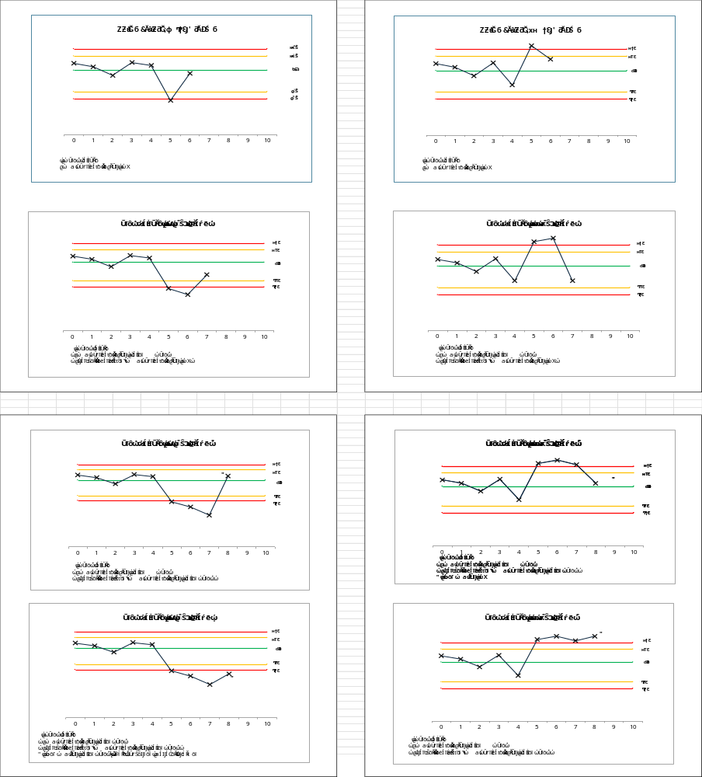
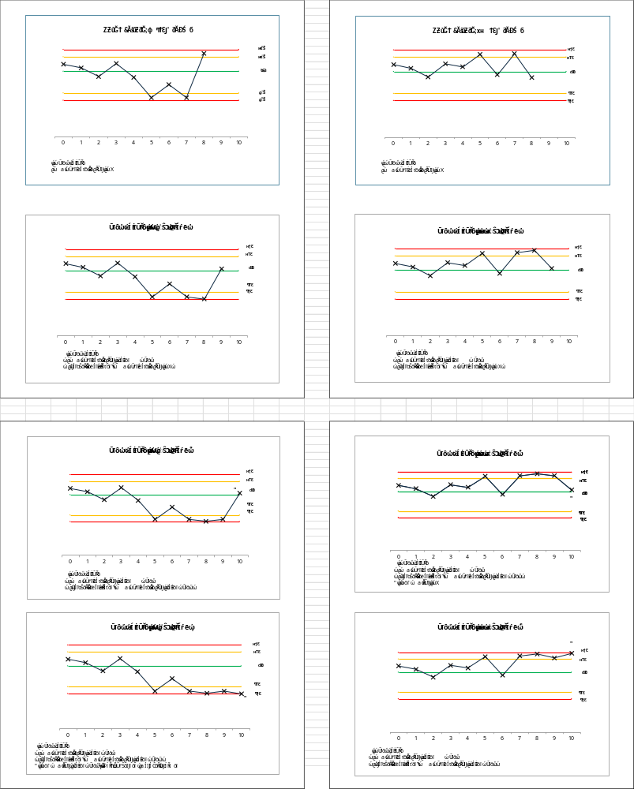

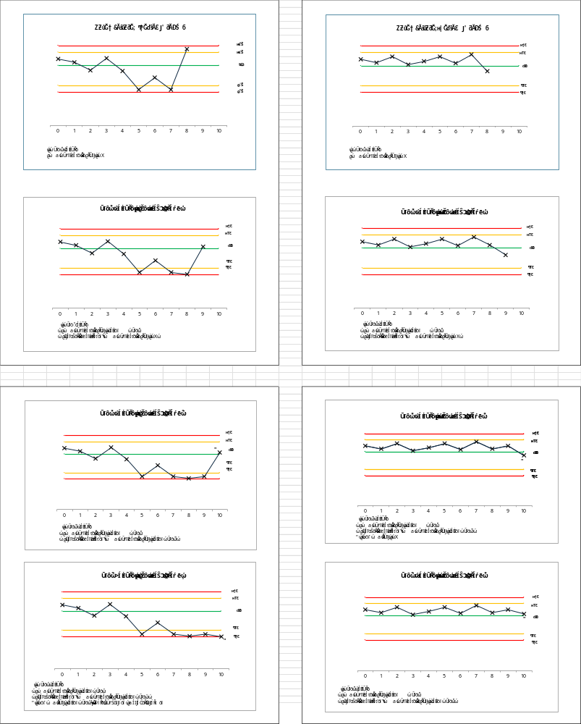

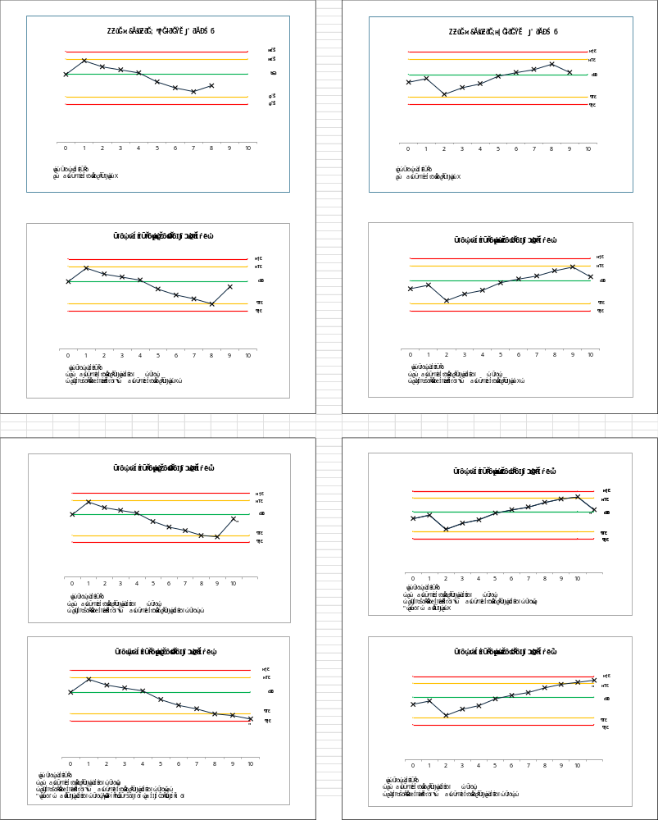

5.3 Method Validation and Ongoing Verification
- All methods are validated before routine use to confirm accuracy, precision, linearity, and detection limits.
- Periodic re-validation is performed after any significant change (New equipment).
- Analysts verify method performance using QC data trends and inter-analyst comparisons.

5.4 Proficiency Testing and Interlaboratory Comparison
- The laboratory participates in proficiency testing (PT) for each accredited parameter.
- PT performance is evaluated using z-scores and included in management review.
- If no PT is available, inter-laboratory comparisons are conducted

5.5 Trending and Review
- All QC data (duplicates, CRMs, calibrations, PT results) are trended per control chart.
- The Laboratory Manager and Laboratory Supervisor jointly review control charts.
- Any observed bias, drift, or degradation of performance triggers a formal Investigation.
- Persistent trends may result in method re-validation, recalibration, or staff retraining.

6. Corrective Action Procedure
- Stop analysis of samples for affected parameter or batch.
- Re-verify instrument verification, calibrate where necessary and perform impact analysis on affected batches.
- Document root cause, corrective and preventive action in the Nonconformance Register.
- Confirm restored control with CRM or duplicate results before resuming routine testing.

7. Records and Documentation
The following records are retained electronically or in bound QC logbooks:
Record | Retention Period | Responsibility
Calibration Certificates | 5 years | Operations Manager
Daily Verification Logs | 5 years | Analyst
CRM Results & Control Charts | 5 years | Supervisor
Duplicate Test Records | 3 years | Analyst
PT/Inter-lab Results | 5 years | Operations Manager
IRQs and Corrective Actions | 5 years | Lab Manager/Supervisor

8. Review
This procedure shall be reviewed annually during management review meetings.

9. References
- ISO/IEC 17025:2017 — Clauses 7.6, 7.7, 7.8
- ILAC G8:09/2019 — Guidelines on decision rules and reporting
- ASTM D3173, D3174, D3175, D5865 — Coal analysis standards
- Laboratory QMS Manual, Section 7 — Quality Control and Validation
10. Revision
Revision no | Content changed | Reason for revision | Date changed
00 | Added PSD and TM under section 2 | Lab will want to add these two parameters in the future for the extension of scope. | 13/04/2026
01 | Add section for the interpretation of control charts and how the deviations shall be addressed | There was a gap in the system with regards to how control charts are assessed, as well as how deviations from the charts will be addressed. | 13/04/2026

